**CONTRACT FOR THE SUPPLY OF STANDARD GOODS**

**SPECIFIC CONTRACT CONDITIONS**

**FOR**

**[MINI BUS]**

**[CONTRACT NUMBER: 25-G004-21]**

**This contract for the Supply of Standard Goods (“Contract”)**  
is entered into between:

The Government of Kiribati through the Ministry of Finance and Economic Development with its office at the address stated in Article 4 of the SCC (hereinafter referred to as the “Procuring Entity”)

and

HANAN with address as stated in Article 4 of the SCC (hereinafter referred to as the “Supplier”), together referred as the “Parties”.

**RECITALS**

WHEREAS the Procuring Entity wishes to receive from the Supplier, and the Supplier is willing to provide to the Procuring Entity, the Standard Goods as more fully defined hereinafter;

WHEREAS the Supplier is ready and willing to accept the Contract with the Procuring Entity, the Parties agree to the following terms and conditions:

### General provisions

The following annexes form an integral part of the Contract.

* Annex A – Condition for Supply of Standard Goods;
* Annex B – Specifications;
* Annex C – General Contract Conditions

### Scope of the Supply of Standard Goods

The Supplier shall provide the Standard Goods described in Annex A to the SCC “Conditions for Supply of Standard Goods” (the “Goods”) on the delivery date or dates (“Delivery Date or Dates”) and in accordance with the “Specifications” set out in Annex B to the SCC and shall remedy defects in conformity in all respects with the provisions of the Contract.

### Payment

* 1. The Procuring Entity shall pay the Supplier in accordance with the terms of the Contract a total amount of (the “Contract Amount”):

|  |  |
| --- | --- |
| **AU$** | $110,680.17 |

* 1. Upon submission of an appropriate invoice by the Supplier in accordance with Part V of the GCC, the Contract Amount shall be paid in AU$ [*in a lump sum [****or****] in accordance with the following payment schedule (delete the table if lump sum)*]:

|  |  |  |
| --- | --- | --- |
| No | Payment Date: | Amount |
| 1st | 31/12/2021 | 80% |
| 2nd | 07/03/2022 | 20% |

* 1. Final payment will be made upon acceptance of the Goods in accordance with Part V of the GCC.
  2. The Supplier shall have sole responsibility for:

1. the payment of all taxes, including any indirect taxes and value-added taxes (VAT) arising out of or in connection with the Contract, whether paid as part of the Contract Amount or not, and
2. the filing of any required tax returns or other information related thereto with the relevant tax authorities.

If any tax must be paid by the Procuring Entity on account of any payment hereunder, the amount of any such tax shall be deducted from the amount payable by the Procuring Entity to the Supplier.

* 1. Payment shall be made to the bank account of the Supplier as specified in Article 4 of the SCC.

### Official Addresses for Notices and Requests

Any notice, or request under the Contract shall be in writing. Such notice or request shall be deemed to be duly given or made when it shall have been delivered by hand, mail or e-mail to the party to which it is required to be given or made at such party's address specified below. In case of a change of contact person, the Party concerned is obliged to inform the other Party in good time.

For the Procuring Entity:

|  |  |
| --- | --- |
| Address |  |
| Country | Republic of Kiribati |
| Attention of | Hon. Vice President, Minister of Finance Dr Teuea Toatu |
| e-mail | hon.vicepresident@mfep.gov.ki |
| Phone |  |

For the Supplier:

|  |  |
| --- | --- |
| Address |  |
| Country |  |
| Attention of | Jenny K Tonganibeia |
| e-mail | admin@hananjk.com |
| Phone | 73022888 |
| Bank account details |  |

### Rights and Obligations of the Supplier

The rights and obligations of the Supplier are strictly limited to the terms and conditions of this Contract that include the GCC and the SCC. Accordingly, the Supplier shall not be entitled to any payment except as expressly provided in this Contract.

### Effectiveness

The Contract shall become effective, as per Clause 9 of the GCC, upon due execution by the Parties and shall continue in full force and effect until the earlier of:

1. complete performance of the Supplier’s obligations under the Contract, including guarantees obligations, and all payments therefore, or
2. termination of the Contract in accordance with Clauses 17 or 18 of the GCC.

### Duration of the Contract

The Contract shall have an overall duration of (in line with Annex A):

|  |  |
| --- | --- |
| Start Date | End Date |
| 31/12/2021 | 05/03/2022 |

### Amending the Standard Terms and Conditions

The following Special Conditions have been agreed by the Parties, and shall replace the referred Clause 00 of the General Contract Conditions, wholly or partly, as described below

*[clearly regulate possible and exceptional amendments of the General Contract Conditions, which have to be approved in advance by the OAG]*

* * * * *

The Parties have agreed on the terms and conditions of this Contract which has been signed in two (2) original copies whereof the Parties have received one (1) copy each.

**FOR THE PROCURING ENTITY FOR THE SUPPLIER**

(date, name and signature) (date, name and signature)

------------------------------------------------------- -------------------------------------------------------

**In witness by**

(date, name and signature) (date, name and signature)

------------------------------------------------------- -------------------------------------------------------

# ANNEX A – CONDITIONS FOR SUPPLY OF STANDARD GOODS

### Goods to be supplied

2 minibuses for MFED

### Delivery date(s)

*05/03/2022*

### Terms of Delivery

*DDP of Incoterms 2021 is recommended*

### Carrier nomination

### Documents to be provided

*Shipping schedule, Invoice, Warranty Period (12 months after use)*

### Packing requirements

*If other or more detailed than Clause 26 in the GCC*

### Other conditions

# ANNEX B – SPECIFICATIONS

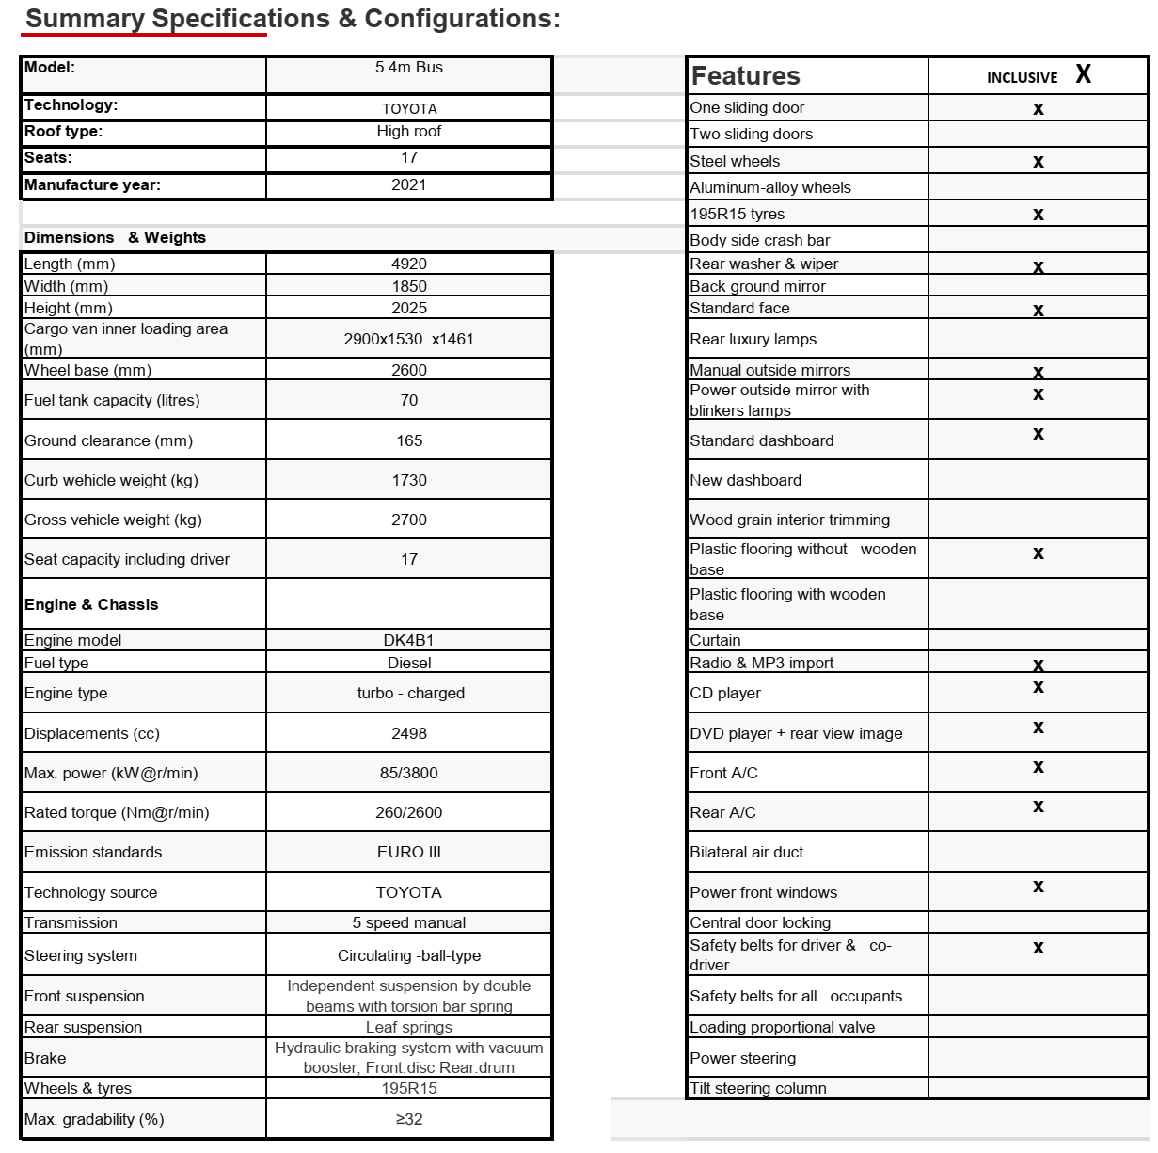

# ANNEX C – GENERAL CONTRACT CONDITIONS

*[Refer to the GCC in .pdf format, replacing this document]*