REQUEST FOR QUOTATION

Ministry of Health and Medical Service
Nawerewere, Bikenibeu
PO Box 68
Republic of Kiribati

To Whom It May Concern,

The Ministry of Health and Medical Services invites Offers from Suppliers to provide the services described in this Request for Quotation (RFQ) as below.

Procurement No: 22-SS003-23
Issue Date: 28th April 2023
RFQ Closing Date: 22nd May 2023 – 17h00 UTC+12 (Tarawa Time)*
Project Title: Request for Quotations (RFQ) for MHMS hire Transport at Betio Hospital and Transport Unit at Nawerewere
This RFQ consists of the following descriptions:
- Instructions on how to submit the quotation
- Specification of the Services to be provided
- Time Schedule for the RFQ/Procurement Process
- Evaluation Criteria and Method
- Specific Contract Conditions for the provision of standard services
- General Contract Conditions for the provision of standard services
- Certificate of Compliance Form
- Availability of Financial Resources Form
A Supplier will be selected based on the competitive procurement procedure described in this RFQ.
Sincerely,
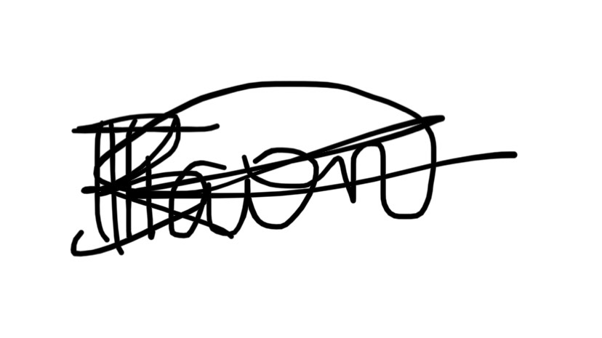
For Secretary, MHMS

Official email address: procurement@mfep.gov.ki (copy to as@mhms.gov.ki)
* Please note that late submissions will not be considered

