INTRODUCTION:
This Construction Specification was prepared for inclusion as part of the Kiribati Insurance Office (KIC) Office in Kiritimati Island. It will govern the standard of building materials, assembly, finishes and general construction processes to be employed in the construction of the new 2 storey office building. It shall be read in conjunction with the project Design Drawings, Structural Specification and National Building Code of Kiribati. Where inconsistencies occur, consult the project designers.
For any alternative replacement materials to use other than those specified herein and as detailed/drawn/noted on the drawings, the proposed material by the contractor shall be similar or superior in all qualities, with provided certification from suppliers and manufacturers.
Any approved alternative materials, different brands including approved variations (in design and the works etc.) proposed by the contractor that require drawing details and specifications, all will become the responsibility of the contractor to prepare as well as at his/their own cost, unless otherwise agreed by all parties prior and during construction. Other variations other than this will be treated as per the signed contract agreement under the variation clause.
Specified branded material will require the contractor to liaise with those branded suppliers/manufacturers, to show the design drawing for the supplier’s additional technical information that may not be included in the detailed drawings, such as but not limited to shop drawings, alternative connections, material sizes and specs. Any quality and structural change should be superior and require certification by the supplier/manufacturer. Whether during the tendering of the works or during the construction, but in any case, the contractor will take full responsibility of any incurred costs if they did not consult with the supplier prior their bidding.

ROOFING:
The roofing/walling shall be 0.42 (or 0.48) mm BMT Stramit® Corrugated cladding in continuous lengths with sinusoidal ribs 16mm high, spaced at 76.2mm centres in accordance with AS1445. Sheeting material shall be protected steel sheet to Australian Standard AS1397, with a minimum yield stress of 550MPa (Grade G550) and an AZ150 zinc-aluminium coating with or without an oven-baked paint film of selected colour. The sheeting shall be fixed to the purlins/girts in accordance with the manufacturer’s recommendations. Suitable fixing screws in accordance with Australian Standard AS3566, Class 3, shall be used at every support with side lap fasteners installed at mid span if required. Sheets shall be laid in such a manner that the approved side lap faces away from the prevailing weather. A minimum of 50mm shall be provided for projection into gutters. Flashings shall be supplied in compatible materials as specified; minimum cover of flashing shall be 150mm. All sheeting shall be fixed in a workman-like manner, leaving the job clean and weathertight.
Repair minor blemishes with touch-up paint supplied by the roof manufacturer. All debris (nuts, screws, cuttings, filings etc.) shall be cleaned off daily.
Refer to Stramit Corrugated: Roof & Wall Cladding Product Technical Manual annexed to this specification for more information.
Stramit Corrugated Roofing Profile:
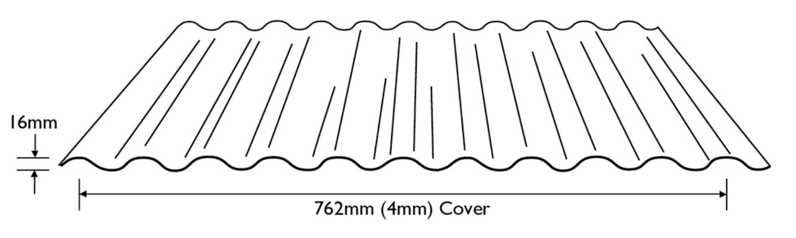

Fasteners:
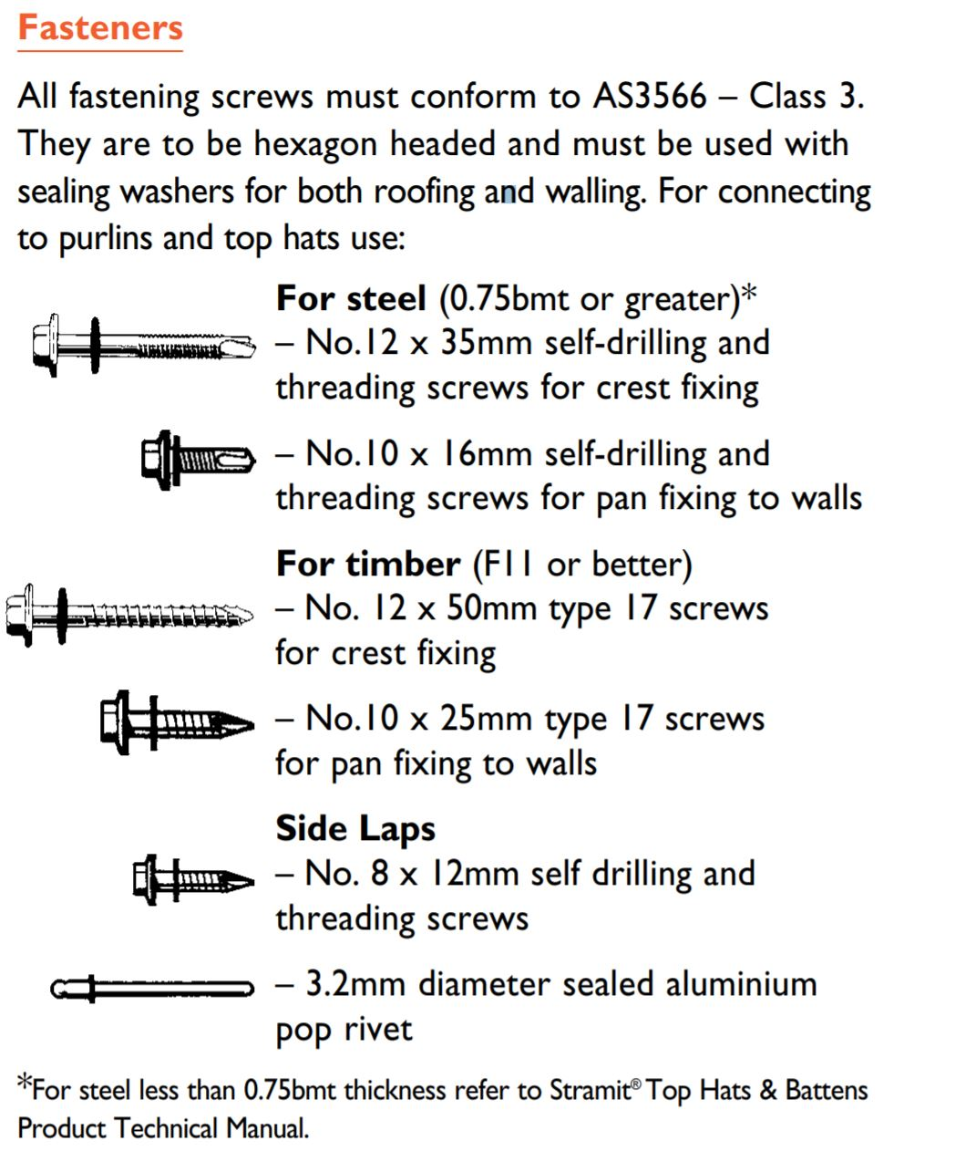

CEILING:
External ceiling:
For all exposed area around eaves at overhangs - use perforated 13mm fiber cement sheet screw fixed to steel purlins and with roof insulation underneath metal roof.
Internal ceiling:
For all internal ceilings use Plasterboard "Knauf OPAL" Ceiling 10mm thick (laid across to u/s of Rafter fixed with 25mm screw) installed in accordance to Knauf Blueprint: Technical Manual for Steel Wall and Ceiling Systems annexed to this specification.

WALLING SYSTEM:
Wall Framing:
Lightweigth Wall Steel Frame "Knauf Sytems & Accessories".
Installed in accordance to Knauf Blueprint: Technical Manual for Steel Wall and Ceiling Systems annexed to this specification.

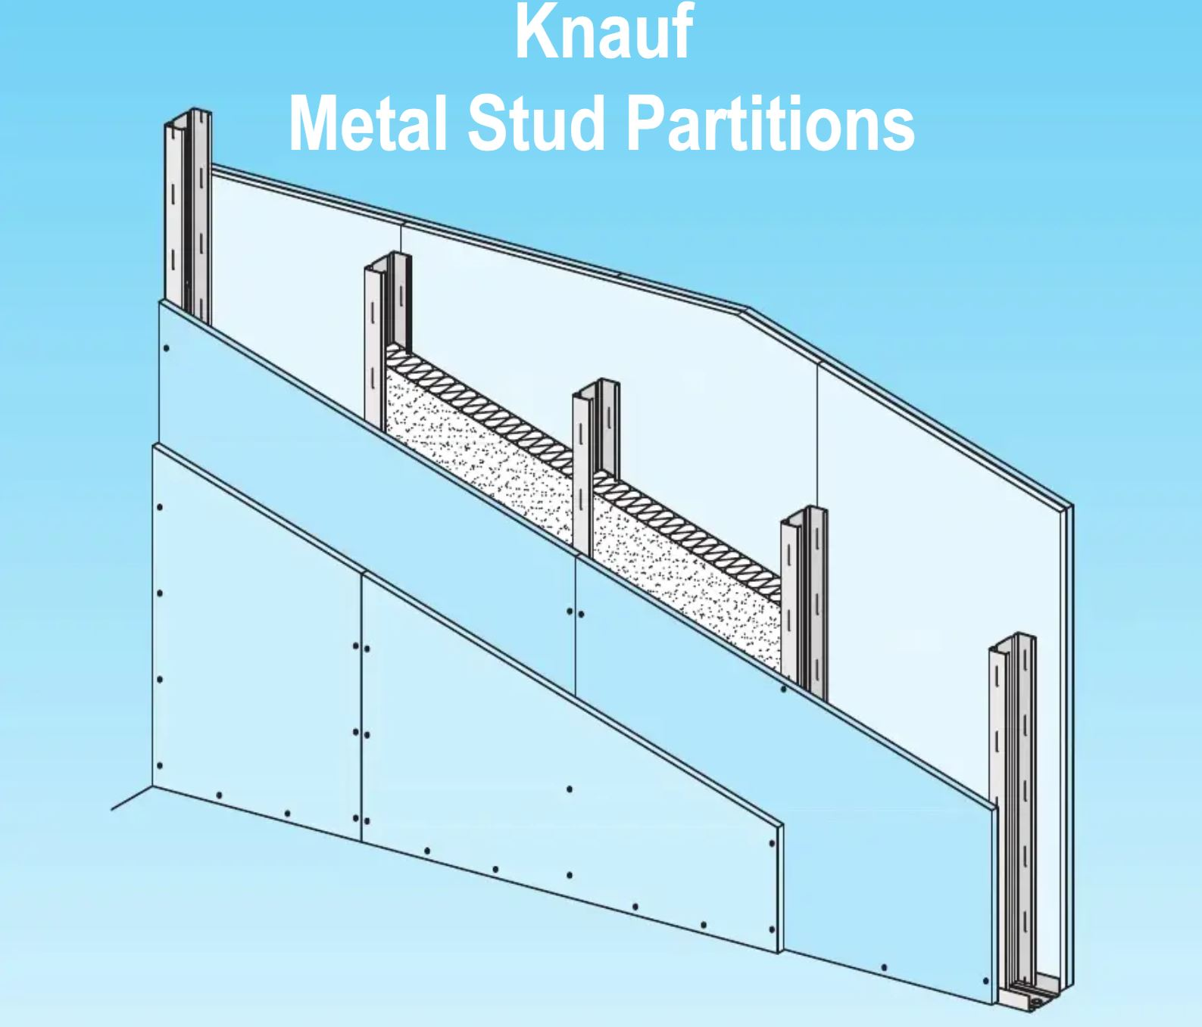

Wall Cladding:
External cladding to use INEX>Weatherboards (with breathable sarking underneath).
Internal Cladding to use13mm plasterboard (knauf fireshield) installed on the inside.
Both claddings installed in accordance to manufacturer’s technical installation manual annexed to this specification.

Weatherboard typical assembly diagram as shown below (refer to drawings and specification notes for actual materials specified):
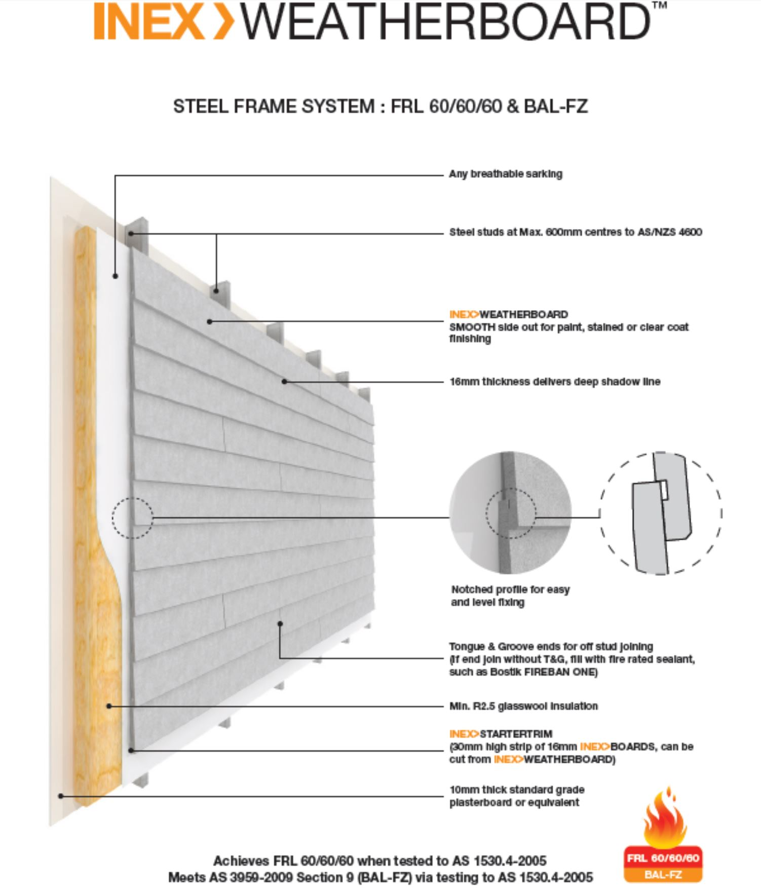

INSULATIONS:
Roof Insulation:
60mm light duty reflective foil faced EarthWool blanket with chicken mesh underneath roofing sheet.
Wall Insulation:
Wall insulation batt R2.5 glasswool.

FLOORING PANELS:
Internal Flooring:
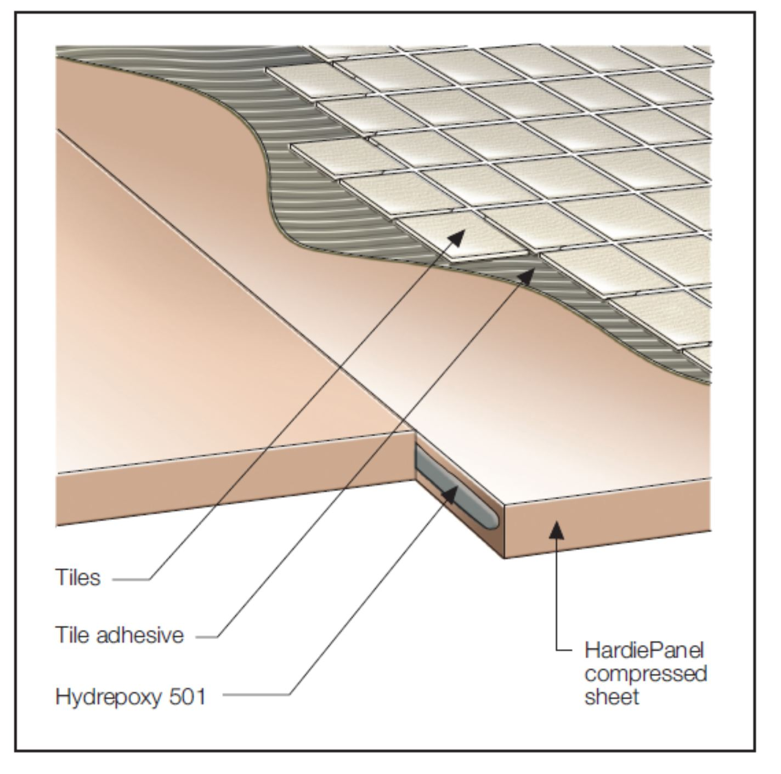
Fibre Cement Sheet 18mm thick HardiePanel compressed sheet (laid with long edge across the joists & fixed with 10g x 40mm CSK self drilling galvanised. Install in accordance to HardiePanel Flooring Installation Manual annexed to this specification.

STRUCTURAL STEEL FRAMING MEMBERS:
1. Main rafter - UB200 22.3
2. Outrigger Rafter (overhang) - PFC 100
3. Purlin - Lipped C Channel 140x45x15x1.55 @ 1000mm max spacing
4. Longitudinal Floor Beam - UB200 22.3
5. Transversal Floor Beam - UB180 16.1
6. Joists – Back to back Lipped C Channel 140x45x15x1.55 @ 500mm max spacing
7. Column – UB200 18.2 OR SHS 150x150x5mm
Refer to Structural Specification attached with this Non-structural specification.

MOISTURE BARRIER:
Install high impact 0.2mm thick polythene moisture barrier beneath concrete slabs/pads/foundation as detailed. Lap joints 150mm and continuously tape. Seal around all penetrations with tape.

Product: 0.2mm ‘Fortecon’ sheet or approved equivalent.

STEEL CORROSION PROTECTION:
All fixings (bolts / washers / nuts / screws / nails / straps) to be fully galvanised.
Avoid contact with copper (e.g. pipework) must be avoided as premature corrosion will occur.
Pre-finished zinc, chrome or cadmium coatings will be rejected.
Coat all welds and exposed bare steel with cold galvanising treatment.

Product: ‘Galmet’ Cold Galvanising – zinc rich coating (grey) or equivalent.

WINDOWS & DOORS GENERALLY:
Both windows and doors are either prefabricated offsite or constructed onsite to suit openings within the metal frame wall. Installed and fixed in accordance to knauf metal wall framing system - technical and installatin guide.
Frames shall fit openings within the prefabricated wall frames, with proper sealings and weatherproofing. It is the contractor’s responsibility to work this out with its suppliers/manufacturer’s. The openings sizes as drawn and detailed shall be maintained; otherwise seek the designer’s approval when deviating from the original plans.

FLOOR & WALL TILE FINISHES:
Install floor tiles to all floor areas.
For dry areas use vinyl tiles.
For wet areas use Mosaic Tile @ Wet Areas (smaller square sizes with light in colour) or to client’s preference.
Set out tiles from the centre of the area. Match edges and align patterns. Arrange the material so that variation in appearance is minimised.
Use adhesive as recommended by the manufacturer for the particular application.
Screed to fall tiles as noted on the drawings.
At wet areas, extend wall tiles to 1800mm height from floor.

Dry Area Floor Tile: “Vinyl Tile”

Wet Area Floor and Wall Tile: “Mosaic Tile (smaller square sizes with light in colour)

RAINWATER COLLECTION / ROOF PLUMBING:
Rainwater collection system is to comply with the requirements of the Kiribati National Building Code.
Provide green UPVC water tank/s complete with mosquito proof inlet & threaded outlet.
Where possible, locate tank stand so that the tank inlet is directly beneath the gutter.
Coordinate finished level of tank stand to ensure the tanks fits beneath the gutter.
Construct tank stand as required, see stand dimensions on plan drawings – refer ‘Concrete’ sections.
Install gutters fix to fascia & steel roofing with galvanised steel straps at 600mm centres.
Provide 1:400 (min) fall toward outlet end. Extend to tank with 100 dia UPVC stormwater pipe, securely strapped to walls and tank with clips at 400 centres.
Install heavy duty threaded fitting to tank outlet & connect to UPVC water supply pipe.
Set out pipework to avoid future damage. Provide permanent protection as required.
Where exposed, fix with plastic saddles at 200mm centres, plugged & screwed to wall.

Products:

Gutter fixing strap: ‘Pryda’ 25 x 1.0mm galv steel strap
OR ‘Mitek’ 30 x 0.8mm galv steel strap or equivalent.

Water supply pipe: ‘Iplex’ 20dia. UPVC pressure pipes & fittings (solvent cement joints) or equivalent.

PUBLIC WATER SUPPLY (where available):
Comply with all regulations of the Kiribati National Building Code and local supply authority.
Submit applications and install water meters as required.

Water supply pipe: ‘Iplex’ UPVC pressure pipes & fittings (solvent cement joints) or approved equivalent.

SANITARY FITTINGS (where applicable and where shown on project drawings):
Install sanitary fittings to manufacturer’s instructions.

Products:
Toilet pan: ‘Caroma’ Concorde P trap (white vitreous china).

Toilet Cisterns: ‘Caroma’ Concorde (white plastic) with single restricted flush.

Toilet Seat: ‘Caroma’ standard (black plastic).

Toilet Paper Holder: ‘Lockwood’ Toilet Roll Holder (satin chrome).

Hand basin: ‘Caroma’ Concorde 500, single centre taphole (white vitreous china).
Hand basin Taps: Standard satin chrome plated brass pillar cock.

Cistern Taps: Standard satin chrome plated brass cistern cock.

SANITARY DRAINAGE (where applicable and where shown on project drawings):
Sanitary drainage to be installed in compliance with the Kiribati National Building Code.
Install inspection / rodding openings at all changes in pipe direction.
Exposed UPVC pipework to be UV stabilised.
Exposed pipes to be fixed with galv steel straps at 400mm CTS, plugged & screwed to wall.
Grated sumps to be fitted with water traps to prevent odours escaping from the system.
Sewer back vents and drains from hand basins& sinks to be 50mm diameter. Refer to schematic pluming plans for additional notes on pipe sizes and other specifications.

Products:
Sewer Pipework: ‘Vinidex’ UPVC sewer pipes & fittings (solvent cement joints) or approved equivalent.

PUBLIC SEWER DRAINAGE (where applicable):
Connect new drainage systems to public sewer.
Comply with all regulations of the Kiribati National Building Code and local authorities.
Submit application for connection as required.

SITE DRAINAGE:
In accordance with Kiribati National Building Code requirements, grade land around buildings to direct surface water away from buildings and toward natural depressions.

RAW MATERIALS:
All gravel and sand shall be supplied from licensed suppliers and designated areas as per MELAD Wild Life Office Recommendations.

