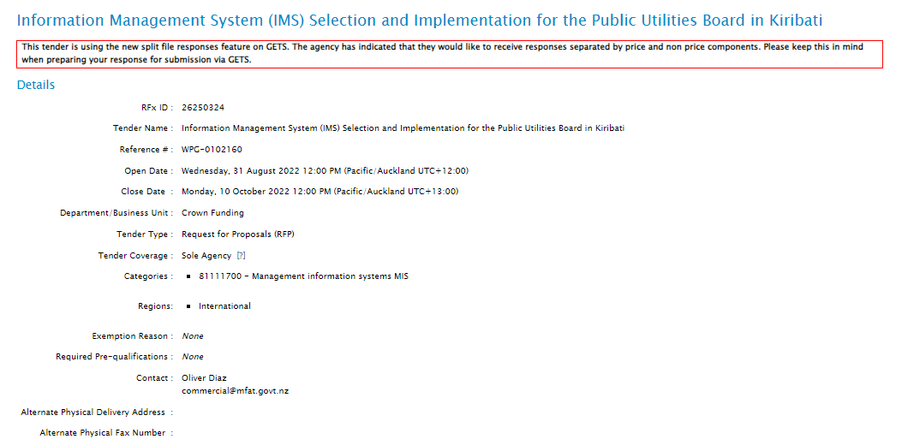
Refer to the pasted link below for full detail:
IMS Selection and Implementation for PUB in Kiribati

